Gage Comparison: Concora to S-Test

2/22/19

**Executive Summary**

In order to compare the Concora test to the S-Test, we proceeded with a Gage analysis of each testing method. A Gage analysis is used to determine the reliability of a measurement system based on its variability. The Concora analysis resulted in a percent tolerance of 29.81 and 4 distinct categories. The S-test analysis resulted in a percent tolerance of 21.25 and 6 distinct categories.

In a Gage analysis, we aim for a low percent tolerance and a high level of distinct categories. A percent tolerance of greater than 30 is considered unacceptable, becoming more reliable as the value approaches zero. When the number of distinct categories is two or less, the study is inadequate for improving the process. Any number of distinct categories above four indicates that the study is broad enough to be used for improvement.

Based on our analysis, the S-test is more reliable with less variation.

Next steps include further analysis of the relationship between Concora and the S-test and their correlation to Flat Crush, DST, and ECT at the converting plants.

**Purpose**

The purpose of this study is to compare the reproducibility and repeatability of two testing methods using Gage R&R. The test methods being compared are Concora and S-Test. Both tests measure sheet strength in the machine direction (MD). Because the test methods measure strength differently, Gage R&R is used to compare a common measurement.

**Procedure**

For both Gage studies, samples were collected to span the range of the measurement system. Ten cross-directional (CD) samples (referred to as Batches) were taken; six samples of 30M, two samples of 26M, and two samples of 36M. A standardized sample cutting procedure was used while collecting samples. From each CD strip, we prepared three sets of three MD test strips (Figure 1). We anonymously chose three operators to run three trials of each CD strip (Table 1). We are assuming that samples will be identical across each Batch.

*Figure 1; Test strip preparation*

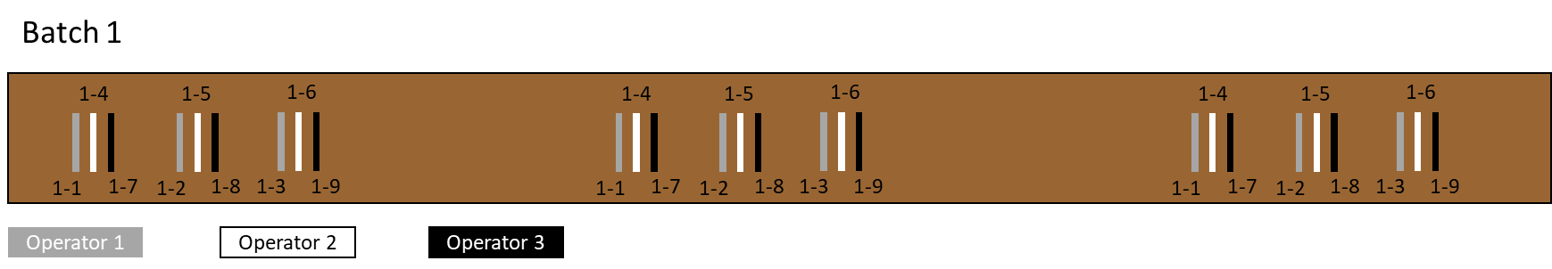

*Table 1; Trial setup*



The S-test data was collected by averaging three tests on each test strip, totaling nine across each Batch.

The Concora data was collected by averaging one test on each strip, totaling three across each Batch.

All data was compiled, and the Gage analysis was ran using Minitab 18.

**Data**

S-Test results are displayed in Figure 2. The S Test Gage study resulted in a tolerance of 21.25% with 6 distinct categories.

*Figure 2*

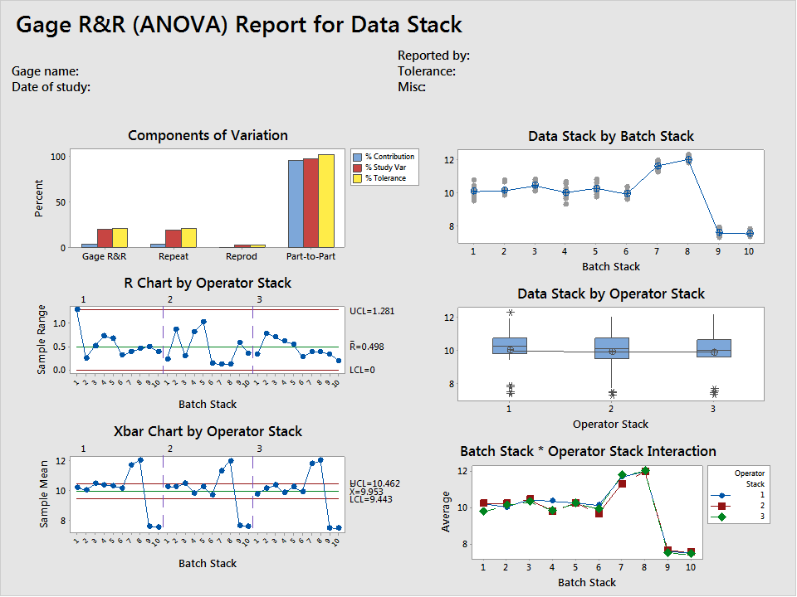

Concora results are displayed in Figure 3. The Concora Gage study resulted in a tolerance of 29.81% with 4 distinct categories.

*Figure 3*

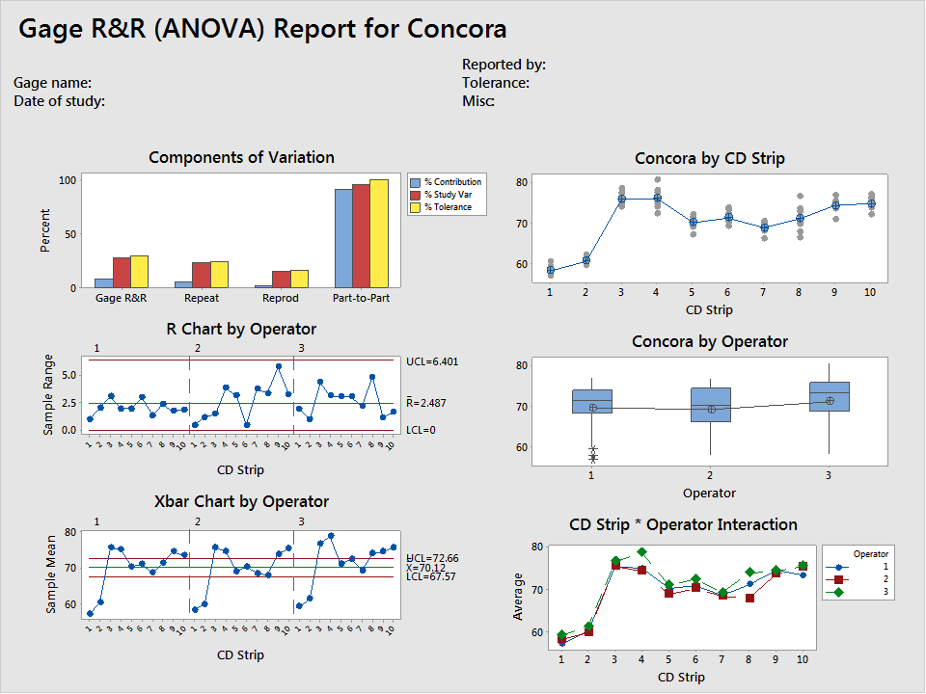

**Discussion**

**Components of Variation**: Summary of the components of variation for the gage study. You want the % contribution from Part to Part variation to be much larger than the contribution from Gage variation.

**R Chart by Operator (Stack)**: This shows the range between the lowest and highest value measured for each part by each operator. Operators are across the top. Perfect is a straight line at 0.

**Xbar Chart by Operator (Stack)**: This shows the average value of all the parts measured by each operator. The operators are across the top. Perfect is the same pattern by each person.

**Concora by CD Strip (Data Stack by Batch Stack)**: This is a comparison of all the parts measure (X Axis) and all the measurement readings (Y Axis). This chart allows you to see if there are any parts that have more variations than others. Perfect is one dot at each point.

**Concora by Operator (Data Stack by Operator Stack)**: This chart shows how all the operators compare.  Each operator is list on the X axis and all their measurements for all the parts measure are listed on the Y axis. Perfect is identical boxes.

**CD Strip* Operator Interaction (Batch Stack * Operator Stack Interaction)**: This compares the average measurement (Y axis) for each operator (color coded) on each part number (X axis). It shows variation by part and by operator which shows if a particular operator is having difficulty with a particular part. Perfect is all overlapping.

**Percent Tolerance:**  This is a measure of Gage variation and confidence. We would like the Gage variation to consume less than 20% of the tolerance of our study to be confident in our decisions. A percent tolerance less than 10 is excellent, 20 is acceptable, 30 is marginal, and anything greater than 30 is considered unacceptable.

**Number of Distinct Categories:** This is describing the resolution of the study. A study resulting in less than two distinct categories indicates that the Gage has no value for controlling the process. A study with exactly two distinct categories indicates that you may control the process but may also be missing information, assuming more risk. A study resulting in four or more distinct categories indicates that the Gage is acceptable for measuring and improving the process.

**Conclusion**

After reviewing the data, the S-test is more reliable. The percent tolerance (21.25%) is very close to the acceptable range, which is particularly impressive when considering the destructive nature of the testing. Destructive tests tend to introduce variation in a process. Our S-test analysis revealed six distinct categories which indicates that the Gage is acceptable for measuring and improving the process.

The Concora data revealed four distinct categories which is acceptable but returned a percent tolerance of 29.81. Based on our analysis, the Concora test is less reliable.

**Recommendation**

Next steps include further analysis of the relationship between Concora and the S-test and their correlation to Flat Crush, DST, and ECT at the converting plants.